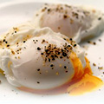  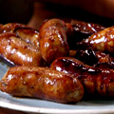  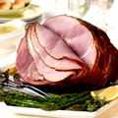  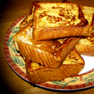 |  | Western Food Menu  Breakfast Set  Toast, fried eggs, chicken ham, chicken sausages and baked beans Coffee or Tea  French Toast served with butter and honey Coffee or Tea  Coddled Egg - toast and half boiled eggs Coffee or Tea  Toast, scrambled eggs, chicken sausages and baked beans Coffee or Tea  Sours  Tomato soup with pesto crouton - RM26  Vegetable soup with garlic crostoni- RM26  Soup of the day Chef’s choice of soup of the day- RM26
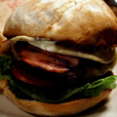  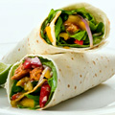  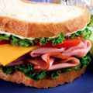  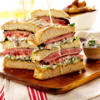 |  | Fusion Menu  Sandwiches  Mediterranean - RM 40  Pan-fried eggplant, tomato and mozzarella sandwich with fries  Ruben Pastrami Sandwich - RM 40  Rye bread topped with sauerkraut, shaved Pastrami and gruyere cheese  Flame Grilled Steak Sandwich - RM 58  Open faced with sautéed onions, gruyere cheese on cibatta  Tandoori Wrap - RM 40  Chicken slices marinated with tandoori spice, wrapped in roti, raita sauce and slice tomatoes, shredded lettuce serve with vegetable pickles  Vegetable Wrap - RM 40  Grill vegetables wrapped in roti with pesto sauce served with pickles  Ham Cheese and Tomato Sandwich - RM 46  On foccacia bread and toasted served vegetable pickles  Triple Decker - RM 40  Arrange lettuce tomatoes, beef bacon, cheese, smoked chicken, cucumber, cooked grill egg, chips and homemade pickle vegetables  100% Beef Cheese Burger - RM 48  Hamburger grill topped with bacon and cheese on hamburger bun, lettuce, tomato, beetroot, cucumber, fried onion rings and fries, homemade pickled vegetable

