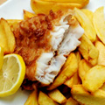  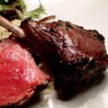  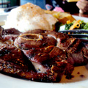  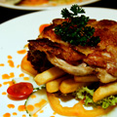 |  | Western Fares Menu  Chicken  a) Fried Cheesy Chicken  Deep fried chicken chop stuffed with double cheese, served with rice, coleslaw and fruit salad.  Choice of sauce : black pepper / bbq /cream  b) Grilled Chicken Chop  Panfried chicken chop laced with sauce. Served with rice, coleslaw and fruit salad.  Choice of sauce : black pepper / bbq /cream  c) Sizzling Chicken Chop  Grilled chicken chop on hot skillet. Served with French fries and steamed vegetables.  Choice of sauce : black pepper / bbq /cream  Lamb  a) Lamb Chop  Juicy lamb rack served with rice, coleslaw and fruit salad  b) Sizzling Lamb Chop  Grilled lamb chop on hot skillet served with fries and steamed vegetables.  Choice of sauce : black pepper  Fish  a) Fish and Chips  Panfried fillet of fish served with fries and tartar sauce  b) Frilled Salmon Steak  Panfried Salmon steak served with vegetables of the day and turmeric sauce.  c) Deep Fried Breaded Fish  Breaded fish deep fried to golden brown served with fries and tartar sauce.
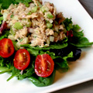  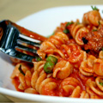  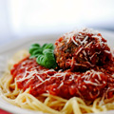 |  | Western Fares Menu  Spaghetti / Pasta  a) Chicken Spaghetti  b) Chicken Bolognaise  c) Beef Bolognaise  Salads  a) Chicken Mayonaise Salad  Combination of chicken meat and salads in thousand island dressing  b) Tuna Salad  Combination of tuna flakes, long beans, tomatoes and green salads in thousand island sauce  c) Garden Salad  Daily fresh green salads served with thousand island dressing
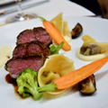  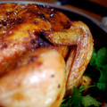  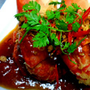  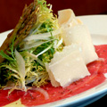 |  | Western Fares Menu  Highlights Menu  a) Pan Seared River Prawns  Spring Vegetable Salad/ Paprika Dressing  b) Black Angus Beef Carpaccio  Sauteed Wood Mushroom/ Parmesan/ Pesto  c) Atlantic Cod  Spicy Sweet Corn/ Spinach/ Dill Beurre Blanc  d) Organic Lamb Two Ways  Loin/ Tortellini/ Celeriac Puree/ Balinese Pepper Sauce  e) 12 Hours Braised Pure Angus Beef Short Rib  Morel Mushroom/ Kohlrabi/ Potato Puree  Highlights Menu  a) Appetizers  Deep-fried crispy eel coated with honey sauce and roasted sesame seeds / Deep-fried crispy aromatic duck  b) Seafood  Choice of fresh garoupa or soon hock, braised with beancurd dough / Wok-baked Australian Lobster with butter and chopped garlic / Live crab braised with vermicelli in spicy sauce  c) Beef Venison & Lamb  Stir fried venison with crispy dough fritters and water chestnuts / Pan fried lamb cutlets marinated with onion and rosemary / Stir fried beef tenderloin with black pepper  d) Chicken & Duck  Crispy roasted chicken topped with fragrant spicy sauce / Roasted chicken fillets served on prawn crackers / Traditional Peking duck  e) Rice & Noodles  Braised e-fu noodles with duo of mushrooms and shrimp roe / Fried egg noodles with assorted seafood and vegetables / Lai Po Heen’s special fried rice

