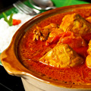  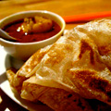  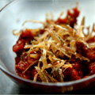  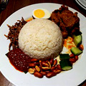 |  | Breakfast Menu  Nasi Lemak  Nasi Minyak  Beehoon Goreng  Sambal Ikan Bilis  Ikan Bilis Goreng  Ayam Masak Merah  Ayam Kurma  Rendang Ayam  Ayam Goreng Berempah  Roti Canai  Kari Ayam

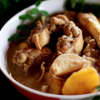  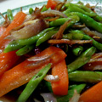  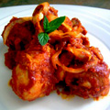  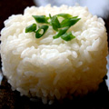 |  | Lunch Menu  Nasi Ayam (Chicken Rice)  Nasi Putih (Plain Rice)  Nasi Minyak  Ikan Tumis Pedas  Ikan Goreng  Ayam Masak Merah  Ayam Goreng  Sayur Goreng  Sambal Belacan  Ayam Kurma
Dinner Menu

Nasi Putih

Nasi Goreng (Fried Rice)

Kari Ayam (Chicken Curry)

Ikan Goreng (Fried Fish)

Ayam Masak Merah

Ikan Goreng Kicap

Sambal Belacan

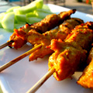  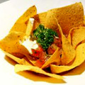  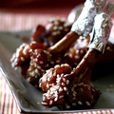  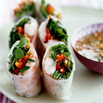 |  | Snacks Menu  Assorted Mixed satays – a Malaysian favorite - RM 35  One dozen mixed chicken, beef and lamb satays with peanut sauce, rice cubes & red onions  Chicken satay - RM 35  12 piece of tender satay sticks grilled and served with peanut sauce and traditional  condiments  Beef satay - RM 35  12 piece of tender satay sticks grilled and served with peanut sauce and traditional  condiments  Vegetable Spring Roll with Sweet and Sour Dip - RM35  Deep fried mozzarella cheese sticks with spicy tomato sauce - RM 35  Golden fried Chicken nuggets with sweet chili dipping - RM 35  Crispy onion rings with tartar Sauce - RM 35  Grilled kofta with mint raita - RM 35  BBQ Chicken boxing - RM 35  Portion of potato wedges sour cream chives - RM 35  Oversized Vegetarian Samosas - RM 35  served with pickled shallots & tamarind

