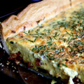  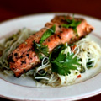  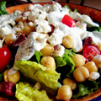  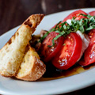 |  | Fusion Menu  Appertizers  Mozzarella, sliced tomatoes, basil and extra virgin oil - RM 32  Turkey ham, mushroom and gruyere cheese quiche with garden greens - RM 30  Seasonal mix salad with pickles and olives served with choice of blue cheese, yogurt, Italian garlic dressing - RM 30  Nicoise salad served with Prawns, Grilled chicken - RM 30  Honey seared salmon with coriander noodle salad - RM 36  Salad of feta cheese, olives, cucumber and red onions in an oregano vinaigrette served with tzaziki and garlic bread - RM 36  Salad of romaine lettuce, croutons, and Caesar dressing served in a Parmesan basket with choice of grilled Prawns, chicken - RM 36  Mains  Garlic pan fried jumbo prawns with bok choy and steamed rice - RM 68  Fish and Chip Batter fried fish of the day served with chips and tartar sauce and lemon wedges - RM 58  Salmon grilled with “cannellini” bean stew and sweet potato puree - RM 68  Crispy baby chicken with risotto cake, arugula and tomato salsa - RM 58  Grill Section: RM 58  Choice of: Grilled lamb cutlets, Beef Sirloin, Fish fillet of the day, Chicken breast,Served with baked potato, caper lemon sauce, gravy sauce, assorted vegetables or mixed salad
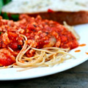  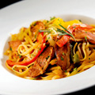  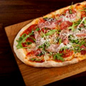  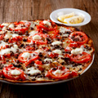 |  | Fusion Menu  Pastas  Spaghetti in a spicy tomato sauce - RM42  King prawn spaghetti in a garlic, olive oil and chili - RM 48  Linguine with a tomato and salmon shards - RM 48  Penne with beef bacon, mushrooms and fresh crème - RM 42  Rigatoni in a tomato and meat sauce - RM 48  Pizza  Pizza with tomato, mozzarella and salame Milano - RM 42  Pizza with tomato, mozzarella and fresh basil - RM 38  Pizza with tomato, mozzarella and grilled vegetable - RM 38  Pizza with tomato, mozzarella, ham and mushrooms - RM 42  Pizza with tomato, mozzarella, assorted seafood and pesto - RM 42

