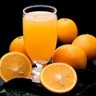  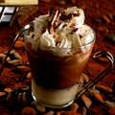 |  | Drinks Menu  Hot Drinks  a) Tea  b) Coffee  c) Café Latte  d) Cappucino  e) Espresso  f) Hot Chocolate  g) Nescafe  Cold Drinks  a) Mango Juice  b) Orange Juice  c) Ice Coffee  d) Ice Chocolate  e) Ice Lemon Tea  f) Ice Nescafe  g) Ice Tea  h) Syrup (with or without lemon)  i) Soft Drinks
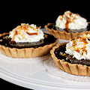  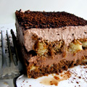  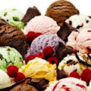 |  | Drinks Menu  Ice Creams  Selection of Gelatomio ice cream - RM 32  > Vanilla  > Coffee  > Chocolate  > Pistacchio  > Stracciatella  > Cinnamon  Deserts  Italian coffee soaked biscuit in a mascarpone cream - RM 22  Hazelnuts and chocolate brownie with vanilla ice cream caramel drizzle - RM 22  Mango New York cheesecake with raspberry coulis - RM 22  Fresh fruit plate RM 18

