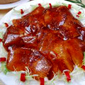  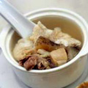  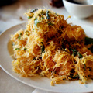  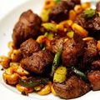 |  | Chinese Menu  廚師推薦Chef’s Recommendation  1. 錦繡中華四小葷 - RM35 每位Person  Combination of four deluxe individual platters  2. 陳參鮑脯花膠湯 - RM60 每位Person  Double-boiled abalone soup with fish maw, premium ginseng & mushrooms in superior broth  3. 千絲奶油蝦球 - RM69 每份Portion  Wok-fried prawns with butter, milk, chili, scented curry leaves  4. 黑椒蘭度牛柳粒- RM58 每份Portion  Wok-fried beef tenderloin cubes with jade kale & cashew nuts in black pepper sauce  5. 蜜抽子姜雞- RM33 每份Portion  Honey-glazed boneless chicken topped with crispy ginger flakes  6. 薄荷爆炒羊柳片- RM56 每份Portion  Wok-fried sliced lamb with pepper mint sauce  7. 馳名北京片皮鴨 (两吃) - RM128 每只Per Duck  Beijing style roasted duck  Roasted skin served with traditional pancake, cucumber, spring onion, & chef’s special duck sauce  請飪选一种鴨肉煮法  Please select your preferred preparation for the duck meat  • 咸菜鴨骨湯 Duck soup with tomato, salted vegetables & sour plum  • 薑蔥炒 Wok-fried duck meat with spring onions & ginger  • 酸菜斩肉件 Duck meat with pickled vegetables  • 鴨崧生菜包 Sautéed minced duck meat & water chestnuts served with lettuce  • 鴨粒蔬菜炒飯 Fried rice with shredded duck meat & vegetables
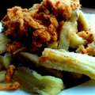  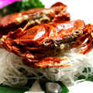  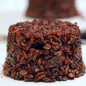  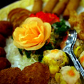 |  | Chinese Menu  餐前小食及拼盤Appetizers & Cold Dishes  8. 草莓醬酥炸白飯魚 - RM25 每份Portion  Crispy-fried white bait accompany with homemade strawberry sauce  9. 黃金炸雲吞 - RM23 每份Portion  ried crispy wanton  10. 點點心意 - RM24 每份Portion  Three combination Dim Sum platter  11. 苹果酱软壳蟹 - RM42 每份Portion  Batter soft shell crabs with apple sauce  12. 酥姜九肚魚 - RM33 每份Portion  Savory bean curd fish with fried ginger & garlic  13. 開心果伴黑糯粟米 - RM24 每份Portion  Tossed black glutinous corn with pistachio nuts  14. 麼麼烤鴨皮蛋卷 - RM23 每份Portion  Beijing duck rolls with cucumber & century egg wrapped in homemade “Momo” skin  15. 香酥肉鬆茄子 - RM22 每份Portion  Fried Belacan eggplants tossed with meat floss
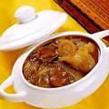  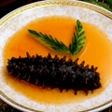  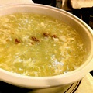  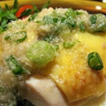 |  | Chinese Menu  燒烤類 Barbeque Dishes  16. 廣陵沙姜浸雞 - RM45 (half brid)  teamed free-range chicken with wild ginger  17. 廣東燒鴨 - RM34  Cantonese roasted duck  18. 蜜汁雞叉燒 - RM34  Home roasted honey chicken  滋味靓汤类 Premium soup  19. 珊瑚松油霸皇羹 - RM138 每位Per Person  Braised shredded lobster meat soup with white truffle oil and caviar  20. 上海蟹粉大花胶丝 - RM128 每位Per Person  Braised shanghai style crab meat soup with premium fish maw  21. 红烧鲍参燕肚 - RM188 每位Per Person  Braised abalone soup with, sea cucumber, fish maw and bird’s nest soup  22. 冬螽草炖官燕 - RM158 每位Per Person  Double-boiled wild Cordyceps broth with free range chicken and birds’ nest  23. 迷你佛跳牆 - RM208 每位Per Person  Mini Monk Jump Over The Wall
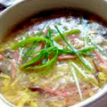  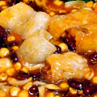  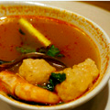  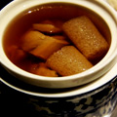 |  | Chinese Menu  湯羹類 Soup Dishes  24. 家鄉魚鰾羹 - RM24 每位Per Person  Traditional fish maw soup with crab meat  25. 浓苋虾茸羹 - RM23 每位Per Person  Olive oil blended spinach soup, Enoki mushroom with minced prawns  26. 瑤柱菜膽燉竹絲雞 - RM33 每位Per Person  Double-boiled black chicken soup with cabbage heart & sun-dried scallop  27. 桃太郎番茄海鮮味增湯 - RM23 每位Per Person  Organic Momotaro tomato Miso soup with assorted seafood  28. 竹笙瑤柱雞片湯- RM22 每位Per Person  Clear sun-dried scallops broth with vegetables, shredded chicken & bamboo piths  29. 酸辣魚鰾手工蝦丸羹- RM23 每位Per Person  Hot & sour soup with shredded fish maw, handmade shrimp ball  30. 每日燉靚湯 - RM22 每位Per Person  Double-boiled soup of the day  (Please ask your service attendant for assistance)
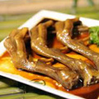  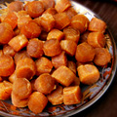  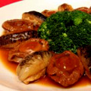  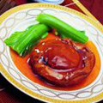 |  | Chinese Menu  海味類 Dried Seafood Dishes  31. 翡翠蠔皇原只湯鮑(2頭) - RM198 每位Per Person  Stewed whole abalone (2 Heads)  Garnished with stir-fried vegetables & crowned with supreme oyster sauce  32. 翡翠蠔皇原只湯鮑(3頭) - RM148 每位Per Person  Stewed whole abalone (3 Heads)  Garnished with stir-fried vegetables & crowned with supreme oyster sauce  33. 红燒溏心吉品鲍 (24頭) - RM498 每位Per Person  Stewed premium Japanese Yoshihama abalone (24 heads)  34. 南非足金鮑（5頭）- RM118 每位Per Person  Stewed 5 heads South Africa abalone  35. 澳洲天亮鮑脯 - RM68 每位Per Person  Sliced Australia skylight abalone  36. 菲力賓海參 - RM20 每位Per Person  Philippine Sea cucumber  37. 潮州大鵝掌 - RM25 每位Per Person  Stewed Goose web  38. 特厚花菇 - RM8 每位Per Person  Supreme black mushroom  39. 日本江瑤柱 - RM13 每位Per Person  Japan sun-dried scallop
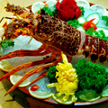  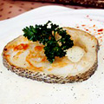  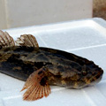  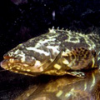 |  | Chinese Menu  生猛海鮮 Live Seafood  An all new dining experience .Please select from the Live Seafood list below & choose your preferred method of preparation.  在一個全新的用餐體驗，請選擇閣下喜好的海鮮和烹飪調法，本餐廳全體職員都很樂意地为您服務  40. 老鼠斑 Polka dot grouper - Market Per 每100克 Per 100g  (Please pre-order two days in advance)  41. 蘇眉魚 Hump head wrasse - Market Per 每100克 Per 100g  (Please pre-order two days in advance)  42. 東星斑 Coral trout (East Star) - RM43.80 每100克 Per 100g  43. 泰星斑 Coral trout (Tai Xing) - RM37.80 每100克 Per 100g  44. 西星斑 Coral trout (West Star) - RM37.80 每100克 Per 100g  45. 筍殼魚 Marbled goby (Soon Hock) - RM29 每100克 Per 100g  46. 龍虎斑 Dragon and Tiger grouper - RM32 每100克 Per 100g
Chinese Menu
生猛海鮮 Live Seafood
An all new dining experience .Please select from the Live Seafood list below & choose your preferred method of preparation.
在一個全新的用餐體驗，請選擇閣下喜好的海鮮和烹飪調法，本餐廳全體職員都很樂意地为您服務

47. 酸菜蜜汁雪魚件 - RM80 每100克 Per 100g
Deep-fried Canadian cod fish cutlet with pickled vegetables in honey sauce

• STEAMED WITH FINE SOYA SAUCE 清蒸
Steamed with light soya sauce, coriander & leek

• CLAY POT SPECIAL 猛火生煲
Steamed in clay pot with ginger, spring onions, coriander & spices

• ASAM STEAMED OR FRIED亚叁蒸或炸
Steamed or fried fish with turmeric, Asam jawa, chili, tomato & lemon grass

• FISHERMAN SAUCE 漁家蒸
Steamed with chili, dried shrimps, onion, Chinese celery & black beans

• BLACK BEAN STEAMED OR DEEP-FRIED豉汁蒸或炸
Black bean with chopped shallot, garlic, chili & Tau Chu sauce

• CRISPY FRIED 蒜香脆炸
Crispy-fried with homemade soya sauce & fragrant garlic

48. 澳洲龍蝦 - Seasonal Price 每100克 Per 100g
Australian lobster
•刺身 Sashimi
•鹹蛋皇炒 Wok-fried with salted egg yolk
•上湯焗 Wok-fried with superior stock
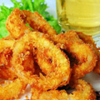  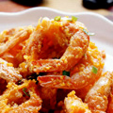  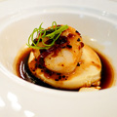  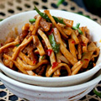 |  | Chinese Menu  帶子類 Australian Scallop Dishes  49. 杏鮑菇韭黃炒帶子 - RM70 每位Per Person  Stir-fried Australia scallops with Pleurotus mushroom & yellow chives  50. X.O醬蘆筍炒帶子 - RM72 每位Per Person  Stir-fried Australian scallops with asparagus in X.O sauce  51. 茄糕泡三鮮 - RM68 每位Per Person  Stir-fried assorted seafood with tomato paste & seasonal vegetables  52. 蟹粉糕帶子釀豆腐 - RM70 每位Per Person  Steamed soft tofu stuffed in crab meat paste & scallops  53. 黑糯粟米炒帶子 - RM70 每位Per Person  Stir-fried black glutinous corn with Australia scallops & seasonal vegetables  蝦球類 Prawn Dishes  54. 暹式酥炸扁蝦 - RM68 每位Per Person  Deep-fried flat prawns with Siam chili sauce  55. 咸蛋醬黃金蝦 - RM69 每位Per Person  Golden prawns with salted egg yolks  56. D24種榴槤蝦 - RM80 每位Per Person  D24 Durian King Prawns  57. 蜜味豉油煎局老虎蝦 - RM36 每位Per Person  Honey Soya glazed King Tiger prawn  58. 洋蔥炸雙圈 - RM43 每位Per Person  Golden fried onion & squid rings  59. 椰絲金鉤炒鮮魷 - RM43 每位Per Person  Stir-fried squids with shredded coconuts, dry shrimps & chili
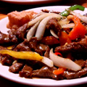  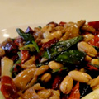  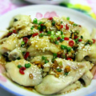  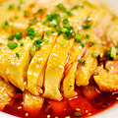 |  | Chinese Menu  家禽類 Poultry  60. 蒜香清遠雞 - RM48 半只1/2 Bird  Deep-fried crispy chicken marinated with garlic & angelica  61. 文加宜白切雞 - RM48 半只1/2 Bird  Steamed free-range chicken with Wincarnis  62. 五香川辣酥骨雞 - RM35 每位Per Person  Braised chicken chunks with Sichuan chili hot sauce  63. 生胡椒紅酒炒鴕鳥肉 - RM52 每位Per Person  Wok-fried ostrich meat with fresh pepper & red wine  64. 黑糯粟米炒鴕鳥肉 - RM52 每位Per Person  Quick stir fried slice ostrich meat with black glutinous corn  65. 湖南花生炒鴕鳥肉 - RM52 每位Per Person  “Hunan” fried ostrich meat with roasted peanuts
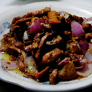  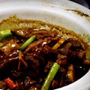  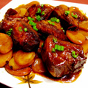  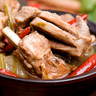 |  | Chinese Menu  牛肉，羊肉 Beef & Lamb Dishes  66. 迷迭香生煲蜜味羊仔骨 - RM55 每位Per Person  Clay pot stewed lamb shoulder with honey, rosemary, chili & garlic  67. 麻辣敦羊排 - RM56 (3 racks)  Fried lamb cutlets with Sichuan pepper, chili & garlic  68. 孜然椒鹽羊柳片 - RM52 每位Per Person  Savory fried slice lamb with cumin & five spices  69. 煎120日西冷扒 - RM45 每100克 Per 100g  Seared 120 day grain-fed beef sirloin  70. 紅蔥急汁炒霖肉牛仔粒 - RM43 每位Per Person  Wok-seared beef rump cubes with onion & Lee & Perrin sauce  71. 肉鬆蒜片牛仔粒 - RM60 每位Per Person  Wok-seared beef tenderloin cubes with crispy garlic & meat floss
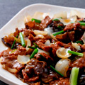  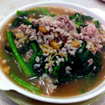  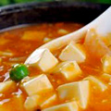  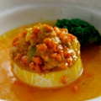 |  | Chinese Menu  豆腐, 蔬菜類 Beancurds & Vegetables Dishes  72. 海堂滑豆腐 - RM36 每位Per Person  Homemade fluffy soft bean curd topped with assorted seafood & vegetables  73. 碧绿蟹粉豆腐 - RM36 每位Per Person  Braised bean curd with “Shanghai” crab meat sauce  74. 瑤柱勝瓜豆腐 - RM38 每位Per Person  Braised Petola gourd with homemade bean curd, sun-dried scallops & garlic  75. 雙味上湯棉花燉蛋, 蔥油原味,韓脆紫 - RM38 每位Per Person  Steamed fluffy egg with two variety of sauce  76. 瑤柱上湯灼莧菜 - RM38 每位Per Person  Poached Chinese spinach with sun-dried scallops  77. 京蔥鮮雲耳 - RM28 每位Per Person  Stir-fried fresh wood ear with leek  78. X.O醬蘆筍 - RM38 每位Per Person  Stir-fried asparagus in X.O sauce  79. 每日新鲜時蔬(本地,香港) - RM33 每位Per Person  Vegetables of the day (Local or Hong Kong)  (Please ask your service attendant for assistance)
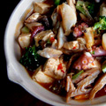  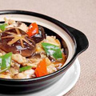  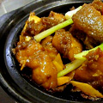  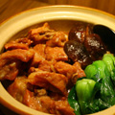 |  | Chinese Menu  四季煲仔菜 Casserole Dishes  80. 鳳脂生煲雪魚- RM38 每位Per Person  Steamed cod fish in clay pot with coriander leaf, scallion & ginger in scented soya sauce  81. 石斑頭腩粉絲煲 - RM78 每位Per Person  Braised grouper head, breast with glass noodle serve in clay pot  82. 芋頭生燜滑雞煲 - RM33 每位Per Person  Simmer chicken chunks with yam, mushroom & sun-dried shrimps  83. 亞參海鮮煲 - RM70 每位Per Person  Clay pot assorted seafood with Asam Jawa sauce  84. 章魚海鮮豆腐煲 - RM55 每位Per Person  Braised tofu with sun-dried octopus, seafood & Vegetables
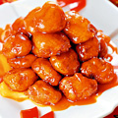  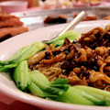  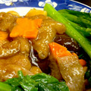 |  | Chinese Menu  健康素食 Well Being Cuisine  85. 黑金粟米羹 - RM23 每位Per Person  Braised duet black glutinous corn soup  86. 八寶佛緣湯 - RM18 每位Per Person  Assorted vegetables soup with glass noodle & bamboo piths  87. 竹笙鼎湖燴上素 - RM28 每位Per Person  Braised bamboo piths with assorted mushrooms & garden vegetables  88. 碧綠豆根燴豆腐 - RM30 每位Per Person  Simmered bean curd with gluten Tou Kan & seasonal vegetables  89. 糖醋齋古嚕肉 - RM34 每位Per Person  Sweet & sour vegetarian chicken  90. 九層塔芹水伴香 - RM28 每位Per Person  Stir-fried sliced lotus roots with celery & Taiwan basil  91. 鮑魚三絲幹撈生麵 - RM28 每位Per Person  Poached wanton noodles with shredded vegetables, abalone & mushrooms  92. 海鮮蔬菜齋炒飯 - RM28 每位Per Person  Fried rice with assorted mock seafood & vegetables
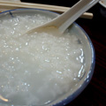  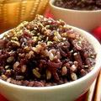  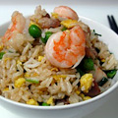 |  | Chinese Menu  飯粥類 Rice & Congee Dishes  93. 海鮮大雜燴局飯 - RM48 每位Per Person  Portuguese baked Japanese rice with assorted seafood, mussel & tomato  94. 蒜香銀魚蝦蛋炒飯 - RM33 每位Per Person  Fragrant fried rice with garlic, eggs, shrimps & silver anchovies  95. 楊州炒飯 - RM36 每位Per Person  Fragrant fried rice with chicken Char Siew & shrimps, “Yang Zhou” style  96. 乾隆皇海鮮炒飯 - RM43 每位Per Person  Assorted diced seafood fried rice with golden sun-dried scallops & vegetable  97. 極品X.O 醬炒飯 - RM38 每位Per Person  Fried rice with chef signature X.O sauce  98. 皇冠炒日本飯 - RM42 每位Per Person  Tobiko crown fried Japanese rice  99. 義香姜茸炒飯 - RM30 每位Per Person  Fragrant fried rice with ginger and sesame oil  100. 细苗白飯 - RM4 每碗Per Bowl  Steamed rice  101. 營養糙米 - RM4 每碗Per Bowl  Brown rice (Unpolished rice)  102. 鱈魚麻油姜絲粥 - RM20 每碗Per Bowl  Cod fish Congee with shredded ginger & sesame oil  103. 白粥 - RM4 每碗Per Bowl  Plain congee
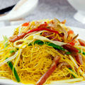  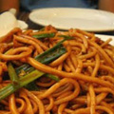  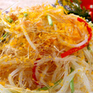  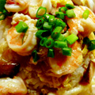 |  | Chinese Menu  麵食類 Noodle Dishes  104. 埔魚芹香菜燜水晶麵條 - RM38 每位Per Person  Wok-fried crystal noodle with Chinese celery, sole fish and bean sprouts  105. 港式桂花炒生麵 - RM50 每位Per Person  Fried eggs noodles with assorted seafood & vegetables Hong Kong style  106. 姜葱滑蛋海鲜河 - RM50 每位Per Person  Wok-fried rice noodles with seafood, ginger & spring onions in egg gravy  107. 酸辣雞絲伴拉麵 - RM33 每位Per Person  Japanese Ramen tossed with shredded chicken in hot and sour gravy  108. 鹹蛋黃炒米粉 - RM33 每位Per Person  Wok-fried rice vermicelli with salted egg yolk  109. 義香乾炒拉麵 - RM30 每位Per Person  Fried Japanese Ramen with ginger and sesame oil
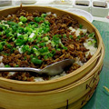  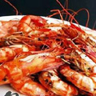  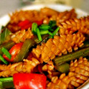  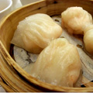 |  | Chinese Menu  套餐 Set Menu A  RM168.00每人（最低2-5人）  RM168.00per person (Minimum 2-5 persons)  華苑飽餃餡  Mini bun combination platter  雲吞肉茶雞鮑魚  Double-boiled abalone soup with free range chicken, wanton in herbal broth  韭黃油泡蒜子海峽中鬥  Wok-seared sliced Pomfret with yellow chives and garlic  河鹽鮮烤明大蝦  Fresh grilled sea prawns with river Murray pink salt flakes  accompany with homemade green sauce  粉絲鮮魷金瓜雜菜煲  Mixed vegetables with organic pumpkin, glass noodle and shredded squids  竹籠義香炒飯  Fragrant sesame oil fried rice with diced chicken serve in dim sum basket  榴槤班戟  D24 homemade durian pancake  精選茶葉  Selected Chinese tea
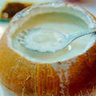  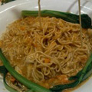  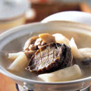  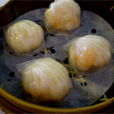 |  | Chinese Menu  套餐 Set Menu B  RM198.00每人（最低2-5人）  RM198.00per person (Minimum 2-5 persons)  蜜餞生蠔卷拼鮑魚燒賣  Honey-glazed dried oyster with abalone “Shao Mai”  石斛蘆根野笙燉雞鮑魚  Double-boiled abalone soup with ShiHu, LuGen and wild bamboo pith  楊枝中鬥拼河鹽炒魚片  Pomfret fillet with Pomelo lime sauce & wok-stir pink Murray salt with fish fillet  D24榴槤海蝦  D24 King Durian Sea prawns  青檸雪葩  Lime sorbet  蝦毛子粉燴海參東菇魚鰾  Braised baked fish maw, mushroom & sea cucumber with shrimps powder sauce  上海蟹粉壽麵  Japanese Somen with shanghai crab meat sauce  椰皇金瓜椰子雪糕  Chilled pumpkin puree with coconut ice-cream  精選烏龍茶葉  Selected Oolong Chinese tea
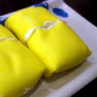  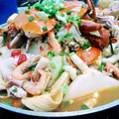  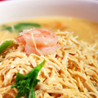  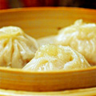 |  | Chinese Menu  套餐 Set Menu C  RM268.00每人（最低2-5人）  RM268.00per person (Minimum 2-5 persons)  蜜瓜煙鴨胸拼鮑魚燒賣  Combination of smoked duck breast, abalone “Shao Mai”  上海黃燜蟹粉龍蝦羹  Braised Shanghai style lobster and crab meat soup  海鮮大煲  Seafood delicacies hot pot (Live cooking)  Fish fillet, prawns, green mussel, scallops, squids, onion, tomato  幹香炒龍口粉絲  Wok-fried glass noodle with sun-dried shrimps, diced chicken and vegetables  榴槤班戟  D24 homemade durian pancake  精選烏龍茶葉  Selected Oolong Chinese tea
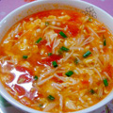  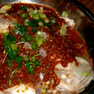  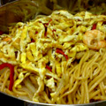  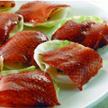 |  | Chinese Menu  套餐 Set Menu 1  RM148.00每人（最低6人）  RM148.00per person (Minimum 6 persons)  馳名北京片皮鴨  Chynna signature Peking duck  味噌番茄叁鲜蛋花羹  Shredded squids, fresh abalone and crab meat Miso broth, organic tomato with egg drops  麻婆汁浸馬友魚  Deep-fried Threadfin (Senangin) with Sichuan Ma Po sauce  蝦毛子冬菇海參扒科甲  Braised sea cucumber with mushroom & winter melon in shrimps sauce  柴魚干貝扒高山娃娃菜  Steamed high mountain cabbage topped with dried scallop and bonito flakes  金沙鴨絲南瓜炒福州麵線  Stir-fried “Fu Zhou” Mee Sua with shredded duck, pumpkin &salted egg  火龍梅子汁香茅凍  Homemade Dragon fruits ice jelly with lemon grass, sour plum and Pandan flavours  精選茶葉  Selected Chinese tea
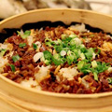  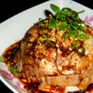  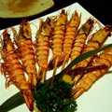  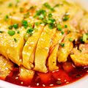 |  | Chinese Menu  套餐 Set Menu 2  RM168.00每人（最低6人）  RM168.00per person (Minimum 6 persons)  華苑飽餃餡  Mini bun combination platter  雲吞肉茶燉雞鮑魚  Double-boiled abalone broth with wanton and free range chicken  油酥姜蒜蒸海峽中鬥  Steamed straits of Melaka Pomfret with savory ginger and garlic  河鹽鮮烤明大蝦  Fresh grilled sea prawns with river Murray pink salt flakes accompany with homemade green sauce  蒜香清遠雞  Deep-fried crispy chicken marinated with garlic & angelica  碧綠鮑魚汁釀烏丸參  Stuffed sea cucumber with mince meat, abalone sauce  竹籠義香炒飯  Fragrant sesame oil fried rice with diced chicken serve in dim sum basket  榴槤班戟  D24 homemade durian pancake  精選茶葉  Selected Chinese tea
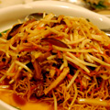  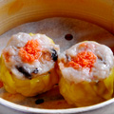  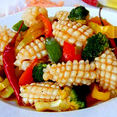  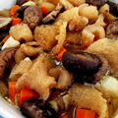 |  | Chinese Menu  套餐 Set Menu 3  RM198.00每人（最低6人）  RM198.00per person (Minimum 6 persons)  蜜餞生蠔卷拼燕液燒賣  Honey-glazed dried oyster with abalone “Shao Mai”  石斛蘆根野笙燉雞鮑魚  Double-boiled abalone soup with chicken, ShiHu, LuGen and wild bamboo pith  楊枝中鬥拼河鹽炒魚片  Combination of Pomfret fillet with Pomelo lime sauce  & wok-stir pink Murray salt with fish fillet  D24榴槤海蝦  D24 King Durian Sea prawns  青檸雪葩  Lime sorbet  干貝扒百花魚鰾冬菇海參  Braised stuffed fish maw, mushroom & sea cucumber with sun-dried scallop sauce  碧綠汁壽麵  Japanese Somen with blended green spinach gravy  椰皇金瓜椰子雪糕  Chilled pumpkin puree with coconut ice-cream  精選烏龍茶葉  Selected Oolong Chinese tea
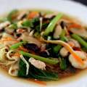  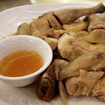  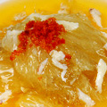  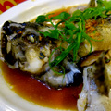 |  | Chinese Menu  套餐 Set Menu 4  RM268.00每人（最低6人）  RM268.00per person (Minimum 6 persons)  蜜瓜煙鴨胸拼燕液燒賣  Combination of smoked duck breast, bird’s nest “Shao Mai”  上海黃燜蟹粉龍蝦羹  Braised Shanghai style lobster and crab meat soup  星洲油滑蒸龍虎斑  Steamed dragon-tiger grouper with Singapore chili style  君度橙盅香酥鴕鳥扒  Savory fried ostrich steak coated with six spices serve in orange cointreau sauce  碧綠足金鮑燴冬菇海參鴨腿  Braised abalone with sea cucumber & mushroom, confit duck leg with shrimps sauce  薄荷蝦湯伴日本壽麵  Japanese Somen with mint and prawn broth  榴槤班戟  D24 homemade durian pancake  精選烏龍茶葉  Selected Oolong Chinese tea
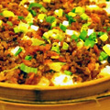  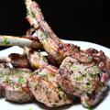  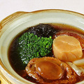  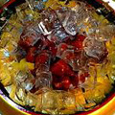 |  | Chinese Menu  套餐 Set Menu 5  RM308.00每人（最低6人）  RM308.00per person (Minimum 6 persons)  冰鎮咕嚕和牛粒  Sweet and sour grade 8 Wagyu beef serve on ice  迷你佛跳牆  Mini monk jump over the wall  干貝酥配津白卷鵝肝鬥片  Cabbage and Pomfret roll with duck Foie-Gras, butter soya sauce  芋茸北海道帶子拼香酥鴨腿  Combination of yam croquette stuffed with Hokkaido  & Confit duck leg with abalone sauce  湖南醬烤澳洲頂級羊排  Seared Aurora lamb cutlets with spicy Hunan sauce  雞粒竹籠義香炒飯  Fried rice with diced chicken and Yi-Xiang sesame oil  椰粥燕液配果王酥  Bird’s nest with coconut syrup, baked durian puff  精選鐵觀音茶葉  Selected Tie Guan Yin Chinese tea
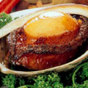  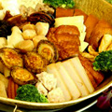  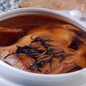  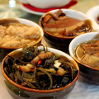 |  | Chinese Menu  套餐 Set Menu 6  RM598.00每人（最低6人）  RM598.00per person (Minimum 6 persons)  特色四小葷  Chynna signature 4 special hors d’ouevre  冬蟲草野菌海味燉雞湯  Double-boiled supreme Cordyceps soup with free range chicken, dried scallop and sea cucumber  至尊八鮮盤菜  Unique Seafood “Pun Choi”  法國龍蝦French lobster, 元鬥鯧pomfret, 墨魚squids, 海蝦sea prawns, 北海道帶子Hokkaido scallop, 魚丸fish balls, 青口green mussels，洋蔥onion and 番tomato  紅燒3頭澳洲鮑魚  Braised 3 heads Australia abalone with garden vegetables  絲苗白飯  Steamed white rice  冰糖高山燕窩  Sweetened wild cave bird’s nest with rock sugar  精選鐵觀音茶葉  Selected Tie Guan Yin Chinese tea
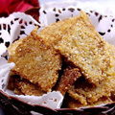  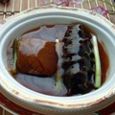  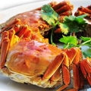  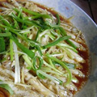 |  | Chinese Menu  套餐 Set Menu 7  RM888.00每人（最低6人）  RM888.00per person (Minimum 6 persons)  冰鎮咕嚕和牛粒  Sweet and sour grade 8 Wagyu beef serve on ice  幹撈黑魚子阿拉斯加雪蟹  Tossed Alaskan king crab with beluga caviar accompany with supreme broth  油酥姜蒜蒸筍殼魚  Steamed marble goby with savory garlic and ginger, homemade king soya sauce  24頭南非鮑海婆參大花膠  Braised 24 head South Africa abalone with premium sea cucumber and fish maw  鮮茄龍蝦煎鍋巴（現場煮）  French Lobster with tomato gravy serves on rice crust  無花果高山野官燕  Sweetened wild cave bird’s nest with rock sugar  榴槤班戟  D24 homemade durian pancake  精選鐵觀音茶葉  Selected Tie Guan Yin Chinese tea

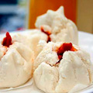  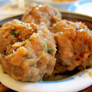  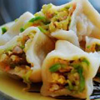  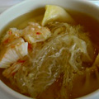 |  |  |  | Chinese Menu  巧手竹籠點心 Steamed in Bamboo Basket  蹄香鮮蝦餃 - RM15  Steamed crystal shrimp dumplings filled with water chestnuts  玉帶乾蒸燒賣 - RM15  Steamed chicken & prawn dumplings with scallop & flying fish roe  瑤柱燕液灌湯餃 - RM58  Bird’s nest dumpling broth with Japanese sun-dried scallops  懷舊雞球大包 - RM14  Steamed chicken bun  蜜汁叉燒包 - RM12  Honey-glazed fluffy barbecued chicken buns  鵪鶉蛋蒸賣 - RM12  Steamed chicken & prawn dumplings with Quail eggs  鮮竹牛肉球 - RM12  Beef balls served on bean curd skin  蒜香魚丸球 - RM12  Savory garlic fish balls  鮑汁鮮竹卷 - RM12  Steamed beancurd rolls with chicken & shrimps in abalone sauce
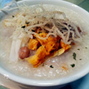  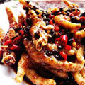  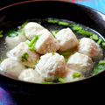  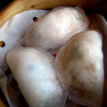 |  |  |  | Chinese Menu  巧手竹籠點心 Steamed in Bamboo Basket  手工豆腐鱼丸 - RM12  Steamed Tofu fish balls  古法糯米雞 - RM14  Traditional glutinous rice with chicken, mushrooms & sun-dried scallops  川椒蒸鳳爪 - RM12  Chicken feet marinated in Sichuan sauce  紅油京川餃子 - RM12  Shrimps & chicken dumplings with soya sauce & chili oil in Sichuan style  雪耳帶子餃 - RM15  Steamed crystal shrimp dumplings filled white fungus and scallops  柴魚花生粥 - RM18  Stockfish & peanut congee  松花蛋雞絲粥 - RM9  Shredded chicken meat congee with century eggs
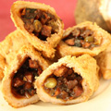  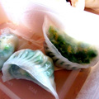 |  |  |  | Chinese Menu  煎炸料理點心 Savory Fried Dim Sum  黑椒荔芋角 - RM12  Yam croquettes filled with black pepper minced chicken & mushrooms  安蝦蘿蔔糕 - RM12  Pan-fried turnip cakes with sun-dried shrimps  鮮蝦韮菜餅 - RM13  Pan Fried Crispy Chive and Seafood Pancake  香芒炸蝦筒 - RM13  Crispy rice paper rolls filled with fresh mango & shrimps  金鈎鹹水角 - RM13  Deep-fried Glutinous rice Puffs Filled with sun-dried shrimps & chicken  農莊雞蛋撻 - RM10  Oven-baked egg tarts filled with custard cream  蟹粉煎餃 - RM18  Pan-fried chicken & shrimp with crab meat dumplings  芝士腐皮卷 - RM14  Deep-fried bean curd rolls with cheddar cheese & shrimps  蜜汁叉燒酥 - RM12  Oven-baked Hong Kong style barbecued chicken puffs  泰式炸蝦餅 - RM13  Deep-fried shrimps cake with Thai sauce  金甲百里香蝦丸 - RM13  Crispy shrimp balls tossed with thyme leave coated with almond flakes  豉汁煎釀青辣椒 - RM13  Wok-seared stuffed green chili with fish mousse in black bean sauce  百花脆豆卜 - RM13  Deep-fried shrimps filled with tofu  X.O 醬炒蘿蔔糕 - RM20  Wok-fried radish cake with X.O sauce
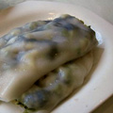  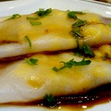  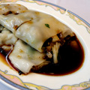  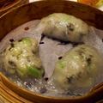 |  |  |  | Chinese Menu  養生素點 Well Being Dim Sum  羊肚菌碧綠粉果 - RM15  Steamed morel with assorted vegetables dumplings  袈裟菜絲卷 - RM9  Steamed vegetarian goose rolls with assorted vegetables & mushrooms  上素三菇腸 - RM9  Steamed rice rolls with assorted mushrooms  地瓜粥 - RM9  Sweet potato congee  手工腸粉 Homemade Steamed Rice Rolls  玉米鮮蝦腸 - RM12  Shrimps & golden maize  香茜帶子腸 - RM15  Fresh scallops & minced coriander  蜜汁叉燒腸 - RM11  Barbecued chicken meat  雪菜雞絲腸 - RM11  Steamed crispy pickle & chicken rice rolls
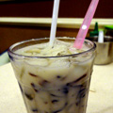  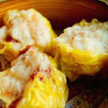  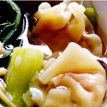  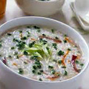 |  |  | Chinese Menu  午套餐 Set Lunch 1  RM78.00每人（最低2人）  RM78.00per person (Minimum 2 persons)  潮州燒賣, 蒜香魚丸球, 辣子鮮竹卷  Steamed chicken & prawn dumpling Teochow style Savory garlic fish ball ,  Bean curd rolls with chicken & shrimps in spicy sauce  泡參雲吞湯  Shrimp “Wanton” consommé & Ginseng  泰式魚餅, 烟鴨胸卷, 安蝦蘿蔔糕  Deep-fried fish cake with thai sauce, Deep-fried shrimp and smoke duck roll,  Pan-fried turnip cakes with sun-dried shrimps  鯧魚粥飯  Pomfret rice congee  椰纖果豆漿涼粉  Chilled Soya & nata de coco with cincau
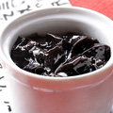  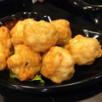  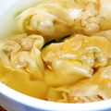  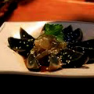 |  |  | Chinese Menu  午套餐 Set Lunch 2  RM78.00每人（最低2人）  RM78.00per person (Minimum 2 persons)  帶子蒸燒賣, 皮蛋賣, 辣子鮮竹卷  Steamed chicken & prawn dumpling with scallop topped with grilled dried meat, Steamed chicken prawn dumpling with century egg, Bean curd rolls with chicken & shrimps in spicy sauce  泡參雲吞湯  Shrimp “Wanton” consommé & Ginseng  芝心蝦丸, 香煎窩貼,百里香蝦丸  Deep-fried shrimp ball with cheddar cheese, Pan-fried chicken & shrimp Dumpling,  Crispy shrimp balls tossed with thyme leave coated with almond flakes  鯧魚粥飯  Pomfret rice congee  椰纖果豆漿龜苓膏  Chilled chinese herbal jelly with nata de coco & soya bean
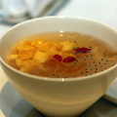  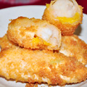  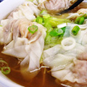  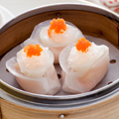 |  |  | Chinese Menu  午套餐 Set Lunch 3  RM88.00每人（最低2人）  RM88.00per person (Minimum 2 persons)  潮州燒賣, 川式干蒸賣, 帶子餃  Steamed chicken & prawn dumpling chew chow style, Steamed chicken & prawn dumpling Sichuan style, Steamed crystal shrimp and scallops dumpling  魔心菇雲吞湯  Shrimp “Wanton” consommé & Morel  泰式魚餅, 芝心蝦丸, 香芒蝦筒  Deep-fried fish cake with thai sauce, Deep-fried shrimp ball with cheddar cheese  Crispy rice paper rolls filled with fresh mango & shrimps  金銀干貝帶子粥  Sun-dried & fresh scallop congee  龍果香茅凍  Chilled aloe vera & lemon grass jelly with Dragon fruit
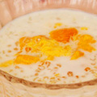  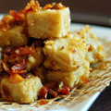 |  |  | Chinese Menu  午套餐 Set Lunch 4  RM88.00每人（最低2人）  RM88.00per person (Minimum 2 persons)  川式干蒸賣,皮蛋賣, 辣子鮮竹卷  Steamed chicken & prawn dumpling Sichuan style, Steamed chicken & prawn dumpling with century egg, Bean curd rolls with chicken & shrimps in spicy sauce  魔心菇海鮮湯餃  Seafood dumpling in broth with Morel  泰式魚餅, 烟鴨胸卷, 芝心蝦丸  Deep-fried fish cake with thai sauce, Deep-fried shrimp and smoke duck roll  Deep-fried shrimp ball with cheddar cheese  X.O 醬炒蘿蔔糕  Wok-fried radish cake with X.O sauce  芒果西米露  Chilled mango sago with vanilla ice-cream
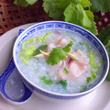  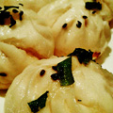  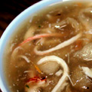  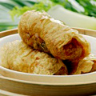 |  |  | Chinese Menu  午套餐 Set Lunch 5  RM88.00每人（最低3人）  RM88.00per person (Minimum 3 persons)  帶子蒸燒賣, 鮑汁鮮竹卷, 雙鮮芹香餃  Steamed chicken & prawn dumpling with scallop topped with grilled dried meat,  Bean curd rolls with chicken & shrimps in abalone sauce  Steamed crystal shrimp dumplings filled with celery and scallop  家乡鱼鳔羹  Traditional fish maw soup with crab meat  蜂巢荔芋角, 肉鬆蘿蔔糕, 生蔥香煎包  Yam croquette filled with minced chicken & mushrooms, Pan-fried turnip cakes with chicken floss, Pan-fried spring onion bun filled with chicken and shrimps  椰汁甘香蝦仁  Shrimps with chili spiced and coconuts milk  香茜薑絲魚片粥  Cod fish congee with shredded ginger & Chinese coriander  白雪紅梅  Chilled raspberry & dragon fruits with coconut ice-cream
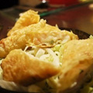  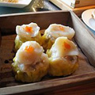  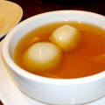  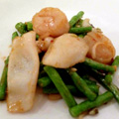 |  |  | Chinese Menu  午套餐 Set Lunch 6  RM108.00每人（最低3人）  RM108.00per person (Minimum 3 persons)  蒜香蒸魚賣, 烤肉帶子蒸燒賣, 蹄香鮮蝦餃  Steamed Fish Balls with garlic, Steamed chicken & prawn dumpling with scallop topped with grilled dried meat, Steamed crystal shrimp dumplings filled with water chestnuts  雲吞肉茶燉雞鮑魚  Double-boiled abalone broth with wanton and free range chicken  西汁明蝦角, 芝士腐皮卷, 肉鬆蘿蔔糕  Shrimp dumplings with homemade lime mayonnaise, Deep-fried bean curd rolls with cheddar cheese & shrimps, Pan-fried turnip cakes with chicken floss  金針花泡帶子花枝片  Australia scallops with sliced cuttlefish, scallops and lily flower  鯪魚蛇豆炒飯  Fried rice with snake bean and fried dace  薑茶湯丸  Ginger syrup with sesame dumpling
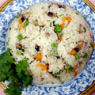  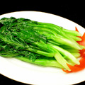  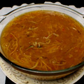  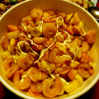 |  |  | Chinese Menu  素食套餐 Vegetarian Set Menu 1  RM148.00每人 RM148.00per person  沙律水果齋蝦  Chilled mock prawns with assorted fruits in salad dressing  酸甜苦辣羹  Braised hot & sour vegetables soup  竹笙鼎湖燴上素  Braised bamboo piths with assorted mushrooms & garden vegetables  清炒芥蘭  Stir-fried Hong Kong jade kale  蔬菜齋炒飯  Fried rice with assorted vegetables  香茅青柠蜜冻  Chilled aloe vera & lemon grass jelly flavored with lime sorbet  精選茶葉  Selected Chinese tea
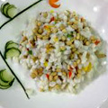  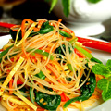  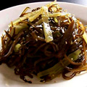 |  |  | Chinese Menu  素食套餐 Vegetarian Set Menu 2  RM148.00每人 RM148.00per person  沙律水果齋蝦  Chilled mock prawns with assorted fruits in salad dressing  八寶佛緣湯  Assorted vegetables soup with glass noodle & bamboo piths  九層塔芹水伴香  Stir-fried sliced lotus roots with celery & Taiwan basil  松仁素魚米  Sautéed corn kernels with pine nuts & diced mock fish  三絲干撈生麵  Poached wanton noodles with shredded vegetables & mushrooms  香茅青柠蜜冻  Chilled aloe vera, lemon grass jelly flavored with lime sorbet  精選茶葉  Selected Chinese tea
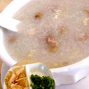  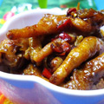  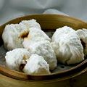  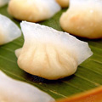 |  |  | Chinese Menu  巧手竹籠點心 Steamed in Bamboo Basket  蹄香鮮蝦餃  Steamed crystal shrimp dumplings filled with water chestnuts  玉帶干蒸燒賣  Steamed chicken & prawn dumplings with scallop & Flying fish roe  蜜汁叉燒包  Honey-glazed fluffy barbecued chicken buns  鮮竹牛肉球  Beef Balls Served on Bean curd Skin  豉汁蒸滑雞  Steamed boneless chicken with black bean  蒜香鱼丸球  Savory garlic fish balls  鮑汁鮮竹卷  Bean curd rolls with chicken & shrimps in abalone sauce  古法糯米雞  Traditional glutinous rice with chicken, mushrooms & Sun-dried scallop  川椒蒸鳳爪  Chicken feet marinated in Sichuan sauce  紅油京川餃子  Shrimps & chicken dumplings with soya sauce & chili oil, Sichuan style  雪耳帶子餃  Steamed crystal shrimp dumplings filled white fungus and scallops  柴魚花生粥  Stockfish & peanut congee  松花蛋雞絲粥  Shredded chicken meat congee with century eggs
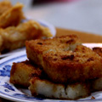  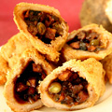  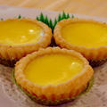  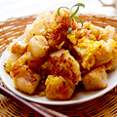 |  |  | Chinese Menu  煎炸料理點心 Savory Fried Dim Sum  黑椒荔芋角  Yam croquettes filled with minced chicken & mushrooms  安蝦蘿蔔糕  Pan-fried turnip cakes with sun-dried shrimps  香芒炸蝦筒  Crispy rice paper rolls filled with fresh mango & shrimps  金鈎鹹水角  Deep-fried Glutinous rice Puffs Filled with sun-dried shrimps & chicken  農莊雞蛋撻  Oven-baked egg tartlet filled with custard cream  芝士腐皮卷  Deep-fried bean curd rolls with cheddar cheese & shrimps  金甲百里香蝦丸  Crispy shrimp balls tossed with thyme leave coated with almond flakes  泰式炸蝦餅  Deep-fried shrimps cake with Thai sauce  豉汁煎釀青辣椒  Wok-seared stuffed green chili with fish mousse in black bean sauce  百花脆豆卜  Deep-fried shrimps filled with tofu  X.O 醬炒蘿蔔糕  Wok-fried radish cake with X.O sauce
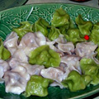  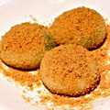  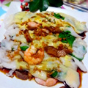 |  |  | Chinese Menu  養生素點 Well Being Dim Sum  袈裟菜絲卷 - RM9  Steamed vegetarian goose rolls with assorted vegetables & mushrooms  上素三菇腸 - RM9  Steamed rice rolls with assorted mushrooms  地瓜粥 - RM9  Sweet potato congee  手工腸粉 Homemade Rice Rolls  玉米鮮蝦腸 - RM11  Steamed with shrimps & golden maize  香茜帶子腸 - RM15  Steamed with fresh scallops & minced coriander  蜜汁叉燒腸 - RM10  Steamed with barbecued chicken meat  甜美句點 Dessert  西檸海底椰  Chilled sea coconut with lemon juice  擂沙湯丸  Black sesame glutinous dumplings coated with crushed peanuts  香茅青檸凍  Chilled aloe vera & lemon grass jelly flavored with lemon sorbet  紅豆沙椰子雪糕  Chilled red bean puree with coconut ice-cream

